**Instagram User Analytics**

**SQL Fundamentals**

**Project Description**

In this project user analysis will be done understand the engagement of user with Instagram. With this analysis, insights will be derived for marketing, product and development teams which will help Instagram to launch a new marketing campaign, decide on features to build for an app, track the success of the app by measuring user engagement and improve the experience altogether while helping the business grow.

**Approach**

Using existing database of Instagram users, SQL queries will be run to user analysis

**Tech-Stack Used: MySQL Tutorial**

* MySQL is a widely used relational database management system.
* It is free and open-source.
* It is ideal for both small and large application.
* It is very easy to write query in MySQL
* MySQL uses a standard form of the well-known SQL data language.
* MySQL works very quickly and works well even with large data sets.

**Insights:**

**A) Marketing:**The marketing team wants to launch some campaigns, and they need your help with the following

1. **Rewarding Most Loyal Users:** People who have been using the platform for the longest time.

Given list contain the names of top 5 oldest users of the Instagram:

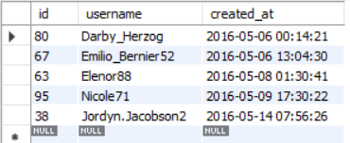

They are the most loyal user of Instagram whom will reward.

Query used:

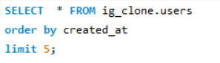

1. **Remind Inactive Users to Start Posting:** By sending them promotional emails to post their 1st photo.

List of inactive Instagram user who haven’t posted even once on Instagram are as follow

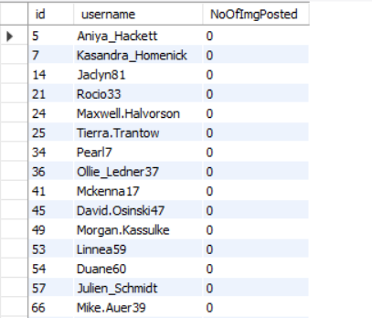

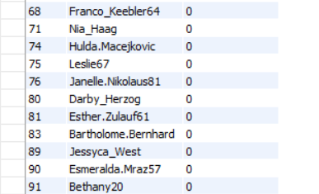

Query used:

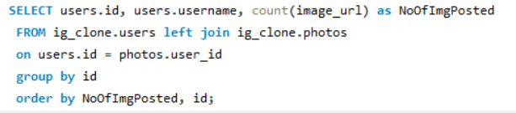

1. **Declaring Contest Winner:** The team started a contest and the user who gets the most likes on a single photo will win the contest now they wish to declare the winner.

Instagram user with username Zack_Kemmer93, user id 52 is the winner of contest with the 48 likes on photo with photo id 145

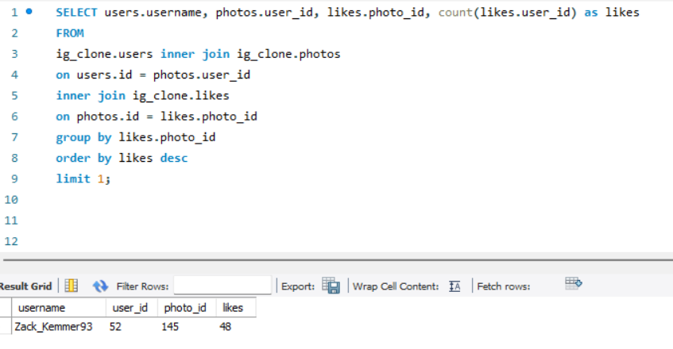

Query used:



1. **Hashtag Researching:** A partner brand wants to know, which hashtags to use in the post to reach the most people on the platform.

List of top 5 most commonly used Instagram hashtag as follow:

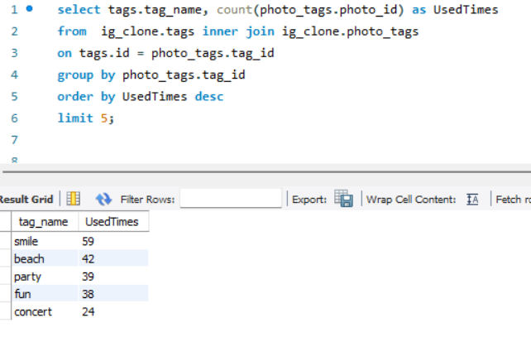

Query used:



1. **Launch AD Campaign:** The team wants to know, which day would be the best day to launch ADs.

Thursday and Sunday are the day on which most of user use Instagram so Thursday are the best days to launch AD Campaign

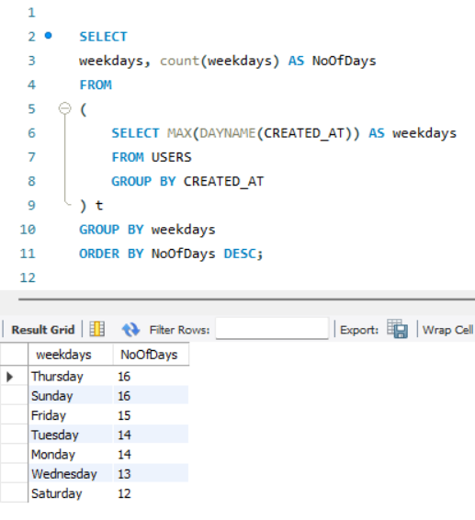

**Query used:**



**B) Investor Metrics:**Our investors want to know if Instagram is performing well and is not becoming redundant like Facebook, they want to assess the app on the following grounds

1. **User Engagement:** Are users still as active and post on Instagram or they are making fewer posts.

* Total no of photo on Instagram: 257
* Total no users: 100
* Therefore on average a user post a photo 2.57 time on Instagram

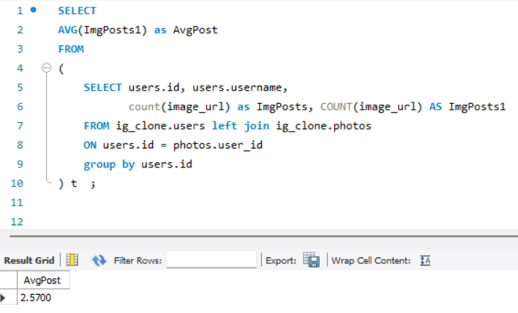

Query used:



1. **Bots & Fake Accounts:** The investors want to know if the platform is crowded with fake and dummy accounts

* There 257 photos on Instagram in total

List of the account with have liked each photos are as follow:

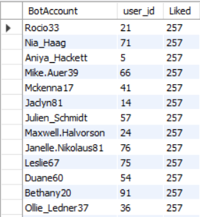

So we can say that these are the fake accounts which we found on Instagram.

Query used:

1.

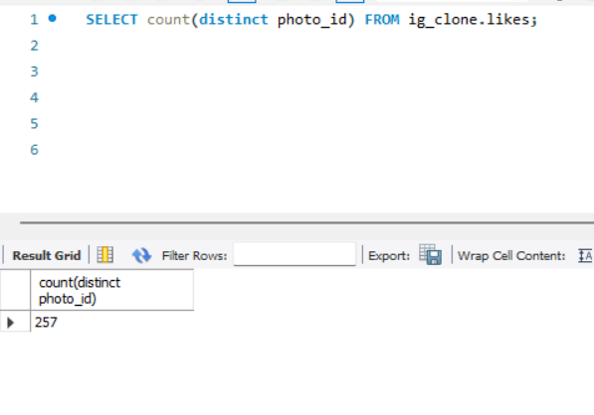

2.

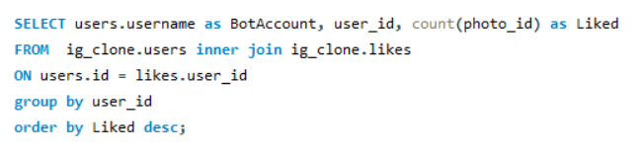

**Result:**

* In this project I have gain practical hands on knowledge about database and how to solve SQL queries.
* This will further help me to perform data analysis in real world scenarios.